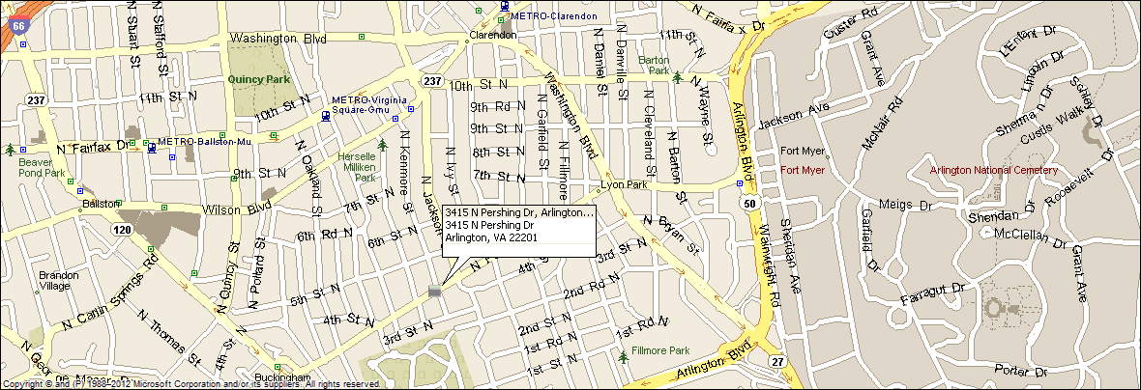
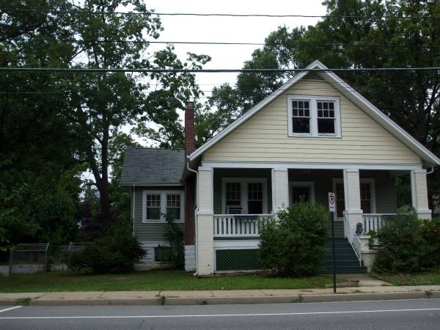
3415 N. Pershing Drive
Arlington, VA 22201
Extensively Renovated Large Bungalow
Great location: Walk to VA Square or Clarendon Metro, Close to DC (5 mins), and major commuting routes.
- Five bedrooms, five full baths, two master suites.
- Two sets of new washer dryers.
- Central a/c, natural gas heat & hot water, all new windows.
- New open concept kitchen w/ Slate appliances & granite.
- Off street parking for 4 cars, carport & 1 car garage
- Large landscaped fenced yard with back yard fire pit.
- Original refinished hardwood floors thru out.
- Established quiet, sought after neighborhood.
- Lease terms: 1 year minimum, no smoking, no use of fire place.

RENT: $4,800.00 / month + utilities, contact Lyndsay Saffer 703-906-3082
Email: safferlyndsay@gmail.com

